Timothy McReynolds

9/23/21

Math 415 Homework 1

1. Write out the first five terms of the sequence satisfying the following difference equation.

$∆t_{n}=1.5(100-t_{n}), { t}_{0}=200$

$t_{0}=200$

$t_{1}=1.5\left(100-200\right)=-150$

$t_{2}=1.5\left(100+150\right)=375$

$t_{3}=1.5\left(100-375\right)=-412.5$

$t_{4}=1.5\left(100+412.5\right)=768.75$

$t_{5}=1.5\left(100-768.75\right)=-1003.125$

1. You owe $500 on a credit card that charges 1.5% interest each month. You pay $50 each month and you make no new charges.
   1. Formulate a dynamical system that models change exactly for the described situation.
 $∆a_{n}=1.015a_{n}-50, a_{0}=500$

  2. Plot and analyze the data. After how many months will the card be paid off?

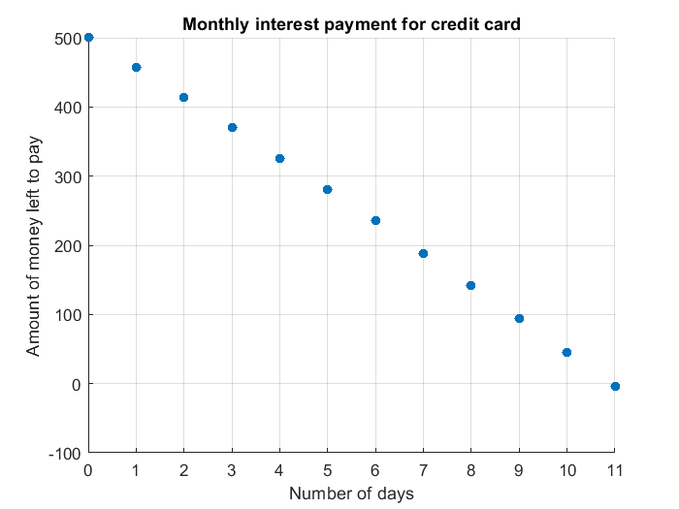

After 11 months the credit card will be completely paid off

1. Cipro is an antibiotic taken to combat many infections. Cipro is filtered from the blood by the kidneys. Each 24-hour period, the kidneys filter out about one third of the Cipro that was in the blood at the beginning of the 24 hour period.
   1. Assume a patient was given only a single 500-mg dose. Use a difference equation to construct a table of values listing the concentration of Cipro in this patient’s blood at the end of each day, for thirty days.
 $∆a_{n}=\frac{2}{3}{(a}_{n}), a_{0}=500$

  2. Assume that the patient must take an additional 500 mg per day. Use a difference equation to construct a table of values listing the concentration of Cipro in this patient’s blood at the end of each day, for thirty days.

* 1. Compare and interpret the two tables.

The first equation is maxed out at zero, while the second equation is maxed out at 15,00. The first table shows that the minimum amount of Cipro the body can have is 0mg. The second table shows that with a 500mg dose each day, the maximum amount of Cipro the body can have is 1500mg.